

**Suraj Arya**

**Practical No:1**

**AIM-Creating a document using different font, changing font size and color, changing the appearance through bold/italic/underline.**

In Microsoft Word, you can change the properties of any text, including font type, size, and color, and make it bold, italic, or underlined (font style).

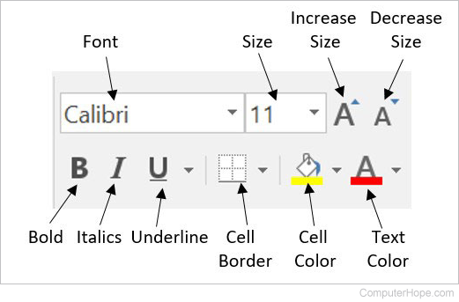

The font settings placement changed after Word 2003, with all the settings placed in the Font section on the Ribbon's Home tab. An example of the font settings in Word

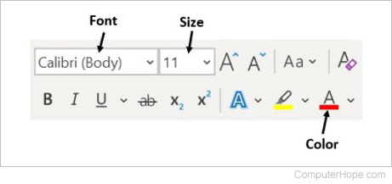

**Changing font color**

To change the font color in a Microsoft Word document, follow the steps below.

1. Highlight the text you want to change.
2. Click the down arrow next to the color icon on the formatting bar or Ribbon. It is usually displayed as the letter "A" with a red underline.
3. After clicking the down arrow, select a color for the text.

**Changing font size**

To change the font size in a Microsoft Word document, follow the steps below.

1. Highlight the text you want to change.
2. Click the down arrow next to the size box on the formatting bar or Ribbon to enlarge or reduce the font size. The default font size is usually 11 or 12.
3. After clicking the down arrow for the size, you see a list of predesignated sizes to select. Some fonts do not scale appropriately to have limited size options.
4. You can also change the font size by clicking and highlighting the current default size. In the picture above, the default is 11. Once highlighted, you can type in a number. For example, if you want to use font size 100, you can type in that number rather than choosing a preset number from the list.

**Changing font style**

To change the font style, including bold, italic, and underline, follow the steps below in a Microsoft Word document.

1. Highlight the text you want to change.
2. Click the B, I, or U option on the formatting bar or Ribbon to change the text to bold italic, or underlined.
3. After clicking the B, I, or U option, the text changes to the selected font style.

,

**Changing font type**

To change the font type in a Microsoft Word document, follow the steps below.

1. Highlight the text you want to change.
2. Click the down arrow next to the font field on the formatting bar or Ribbon. (If you want to change the font to bold, italic, or underlined, click the B, I, or U on the format bar.)
3. After clicking the down arrow for the font, select the desired font from the list of installed fonts on your computer, like Arial, Calibri, and Times New Roman.

**Practical No:2**

**AIM - Create, Save, Run and Print the Power Point Presentation**

**Create a presentation**

1. Open PowerPoint.
2. In the left pane, select New.
3. Select an option:
   * To create a presentation from scratch, select Blank Presentation.
   * To use a prepared design, select one of the templates.
   * To see tips for using PowerPoint, select Take a Tour, and then select **Create.**

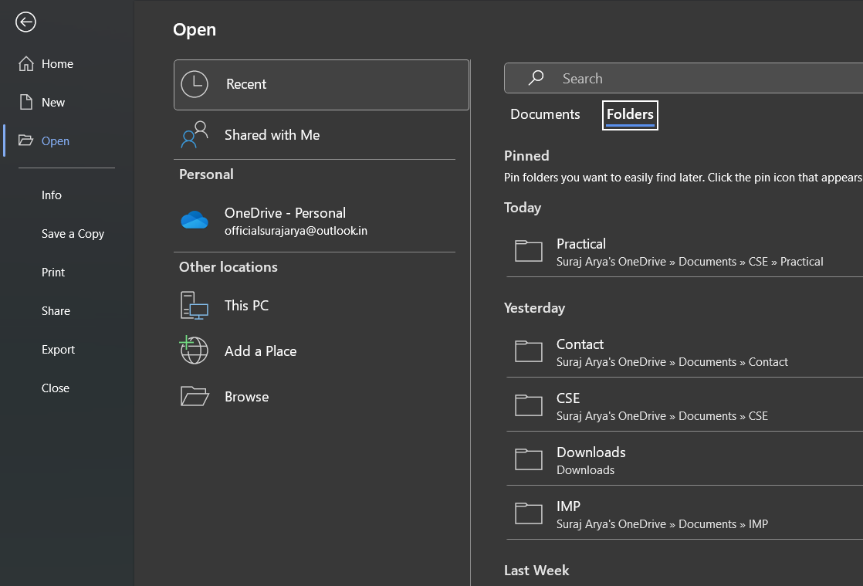

**Save the Presentation**

1. On the **File** tab, select **Save.**

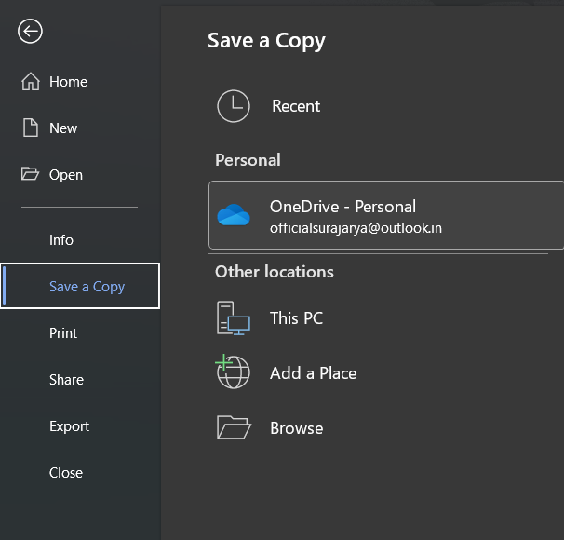

2. Do of the following:

* To save to your local drive, such as your laptop, a flash drive, CD or DVD drive, select **Computer**.
* To save to a SharePoint Library, select SharePoint.

3. Under **Save As** > **Recent Folders**, select **Browse**, pick a path and file folder, and then name the file.

4. Select **Save.**

**Print the presentation**

1. Select **File > Print.**
2. For **Printer,** select the printer you want to print to.
3. For **Settings,** select the options you want:

* **Print All Slides:** To print each slide on a single sheet or change to just print a range of slides.
* **Slides:** From the drop-down, choose to print all slides, selected slides, or the current slide. Or, in the Slides box, type which slide numbers to print, separated by a comma.
* **Print Layout:** Choose to print just the slides, just the speaker notes, an outline, or handouts. The number of slides per page is also an option, an effective way to save paper.

The Outline prints only the text in the slides, without images. The Notes of a presentation show the slide and the related speaker notes below it. If you choose to print Handouts, you can print several slides on one page using a variety of layouts, some with space for note- taking.

* **Color:** Choose whether you want color, grayscale, or pure black and white.
* **Edit Header & Footer:** Select to edit the header and footer before printing.

1. For **Copies,** select how many copies you want to print.
2. Select **Print.**

**Practical No:3**

**AIM- Working on spreadsheet like adding, deleting, merging cells, layout and style.**

**Adding**

You can choose to list cell references of numbers that you want to add with the SUM function. However, this means that you will have to list all the cell references you want to add

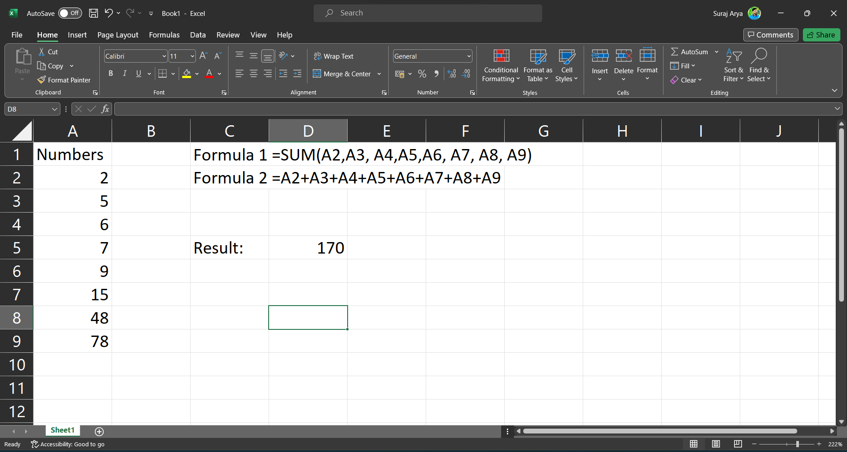

1. The second approach is more helpful when you have a lot more that you want to calculate. It is one of the easiest ways to see just how powerful this function actually is.



With that said, you should know that the SUM function does not limit you to a single column or row. When you are dealing with hundreds of rows and columns that need to be calculated, the SUM function really comes in handy.

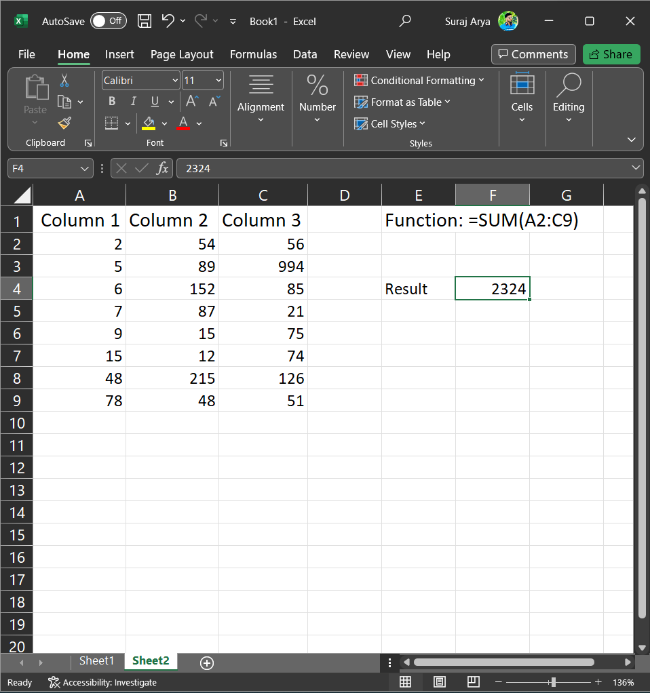

You could also just select all the numbers that you want to calculate, and their sum will be listed below. If you right-click on the area on the bottom, you can choose the results you want to get after selecting the columns and rows.

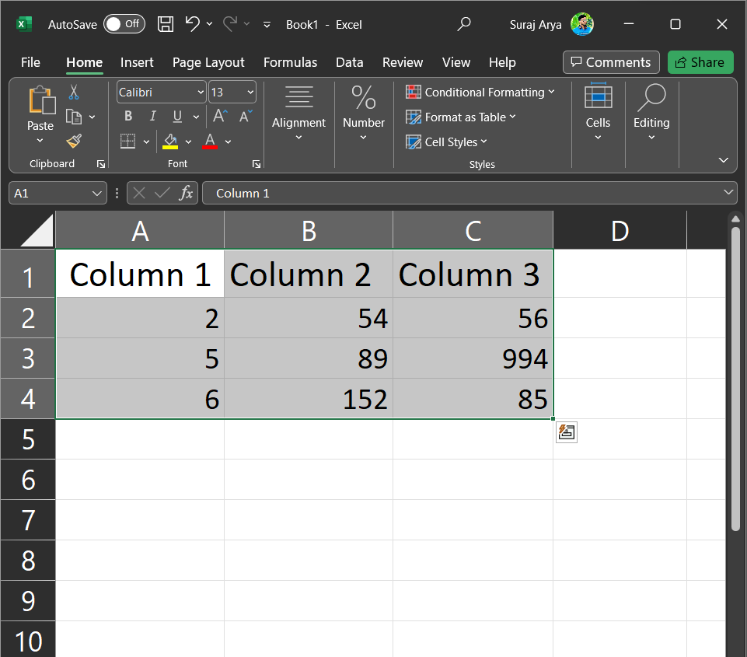

Another great thing is that the SUM function will change accordingly. This means that if you have deleted some rows or columns included in the SUM function, it will update the results.

**Delete**

* Right-click the Sheet tab and select Delete.
* Or, select the sheet, and then select Home > Delete > Delete Sheet.

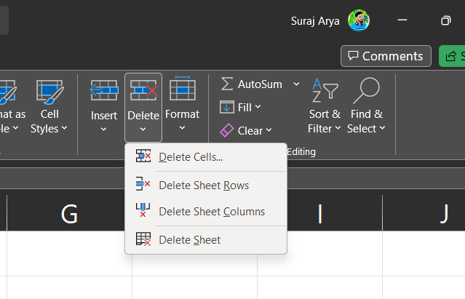

**Merging Cells**

* Column names in your spreadsheet match the field names you want to insert in your mail merge. For example, to address readers by their first name in your document, you'll need separate columns for first and last names.
* All data to be merged is present in the first sheet of your spreadsheet.
* Data entries with percentages, currencies, and postal codes are correctly formatted spreadsheet so that Word can properly read their values.
* The Excel spreadsheet to be used in the mail merge is stored on your local machine. in the
* Changes or additions to your spreadsheet are completed before it's connected to your mail merge document in Word.

**Layout and Style**

You can also create customized styles that reflect your company or personal branding by taking the following actions:

1. Select a single cell in your worksheet.
2. Apply your favorite formatting options to the cell. A built-in style may be the easiest starting point. Then, you can tweak it to add your own flair.
3. Click the Home tab on the ribbon and choose Cell Styles to access the Cell Styles Gallery.
4. Now, choose the New Cell Styles option (It's near the bottom.)
5. Enter the name for your new style in the Style name box.
6. Excel lists the formatting options applied to the selected cell for your reference.

**Practical No:4**

**AIM-Apply Spelling checker, grammar mistakes, thesaurus in a document.**

**Spelling checker**

Step 1: On the navigation menu bar click on the File option.



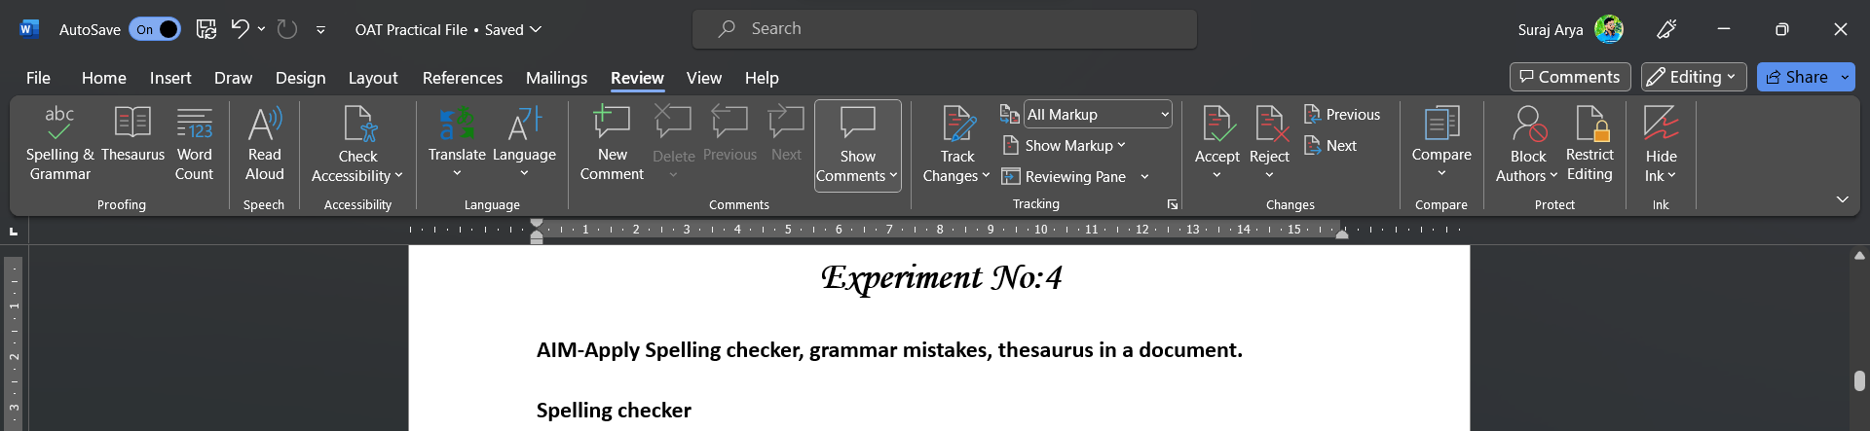

Step 2: Next click on the option button as shown in the figure:

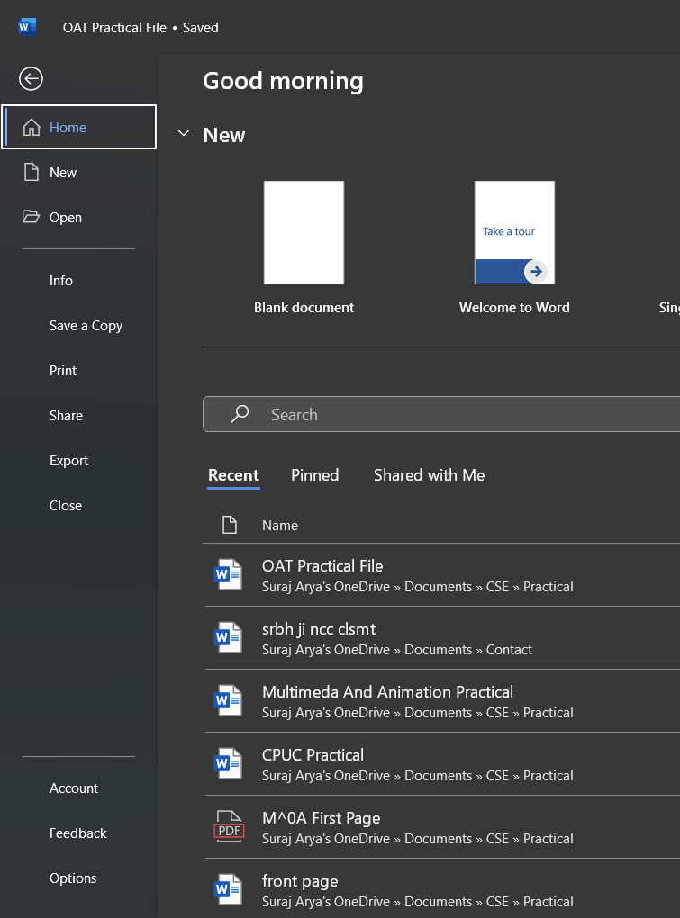

Step 3: A word **option** dialog box will appear on the screen.

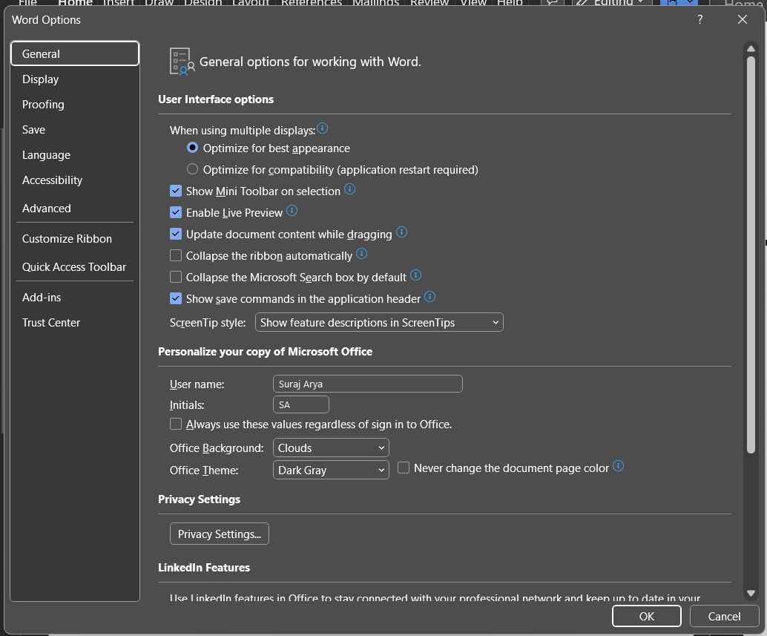

Step 4: Now select the **Proofing** option from the left menu as shown in the figure:

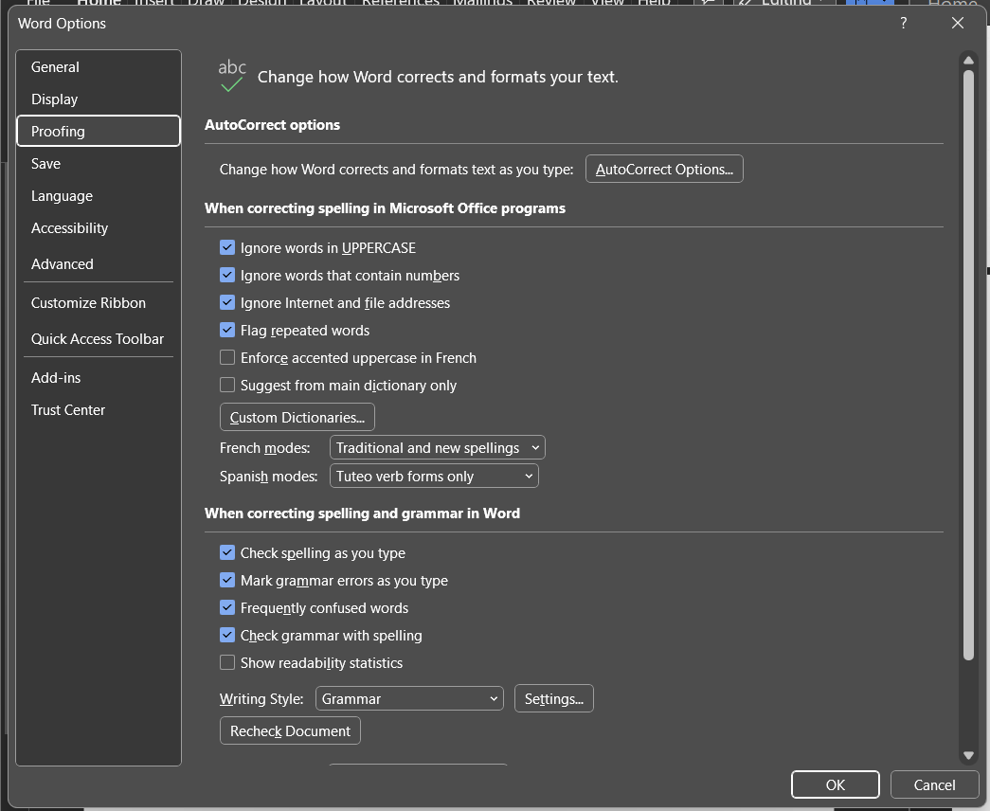

Step 5: Check all boxes as **shown in the figure:**



Step 6: Next click on the **OK** button.





1. By default, Editor checks for several categories of issues, and the suggestions may or may not suit your writing style. To finely tune Editor for suggestions you want, do the following



2. In the Word Options dialog box, next to **Grammar & Refinements**, choose **Settings**.



3. Scroll through the list of options. Select issues you want Editor to check, and clear the issues you want Editor to ignore.

**Practical No:5**

**AIM- Creatingtable, formatting cells, use of different border styles, shading in tables, merging of cells, and partition of cells, inserting and deleting a row in a table in MS word document.**

**Create a Table**

The following steps will help you understand how to create a table in a Word document.

Step 1- Click the Insert tab followed by the Table button. This will display a simple grid as shown below. When you move your mouse over the grid cells, it makes a table in the table that appears in the document. You can make your table having the desired number of rows and columns.

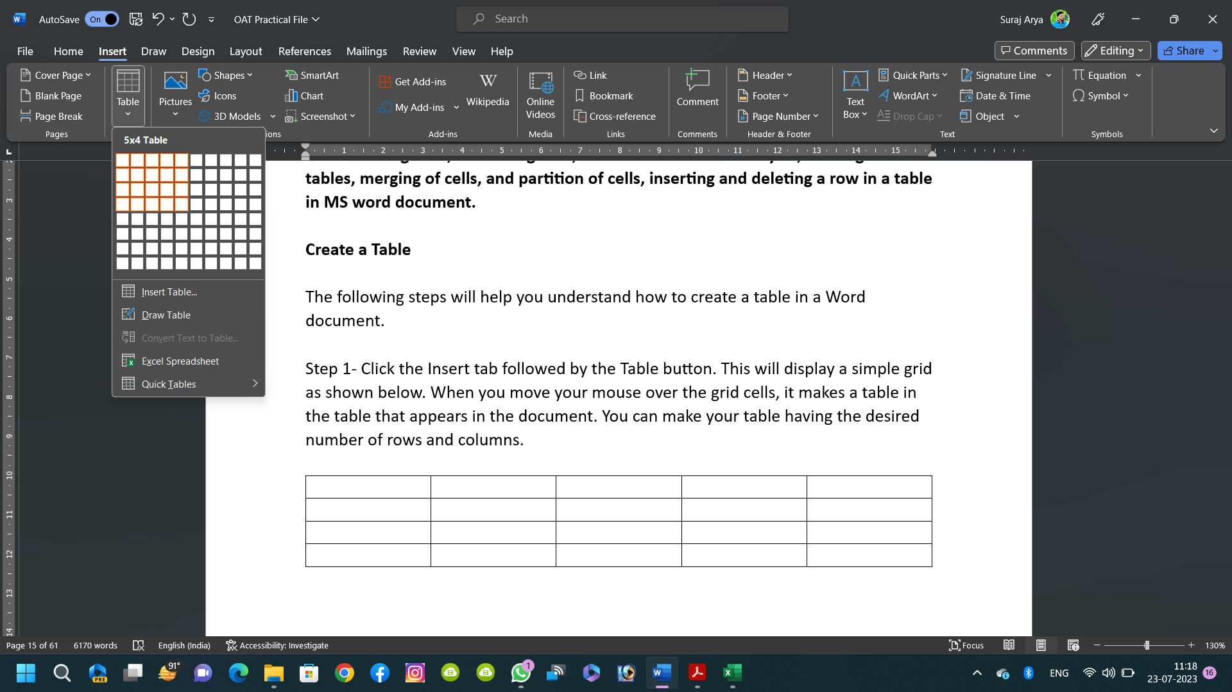

Step 2 Click the square representing the lower-right corner of your table, which will create an actual table in your document and Word goes in the table design mode. The table design mode has many options to work with as shown below.



Step 3 This is an optional step that can be worked out if you want to have a fancy table. Click the Table Styles button to display a gallery of table styles. When you move your mouse over any of the styles, it shows real time preview of your actual table.

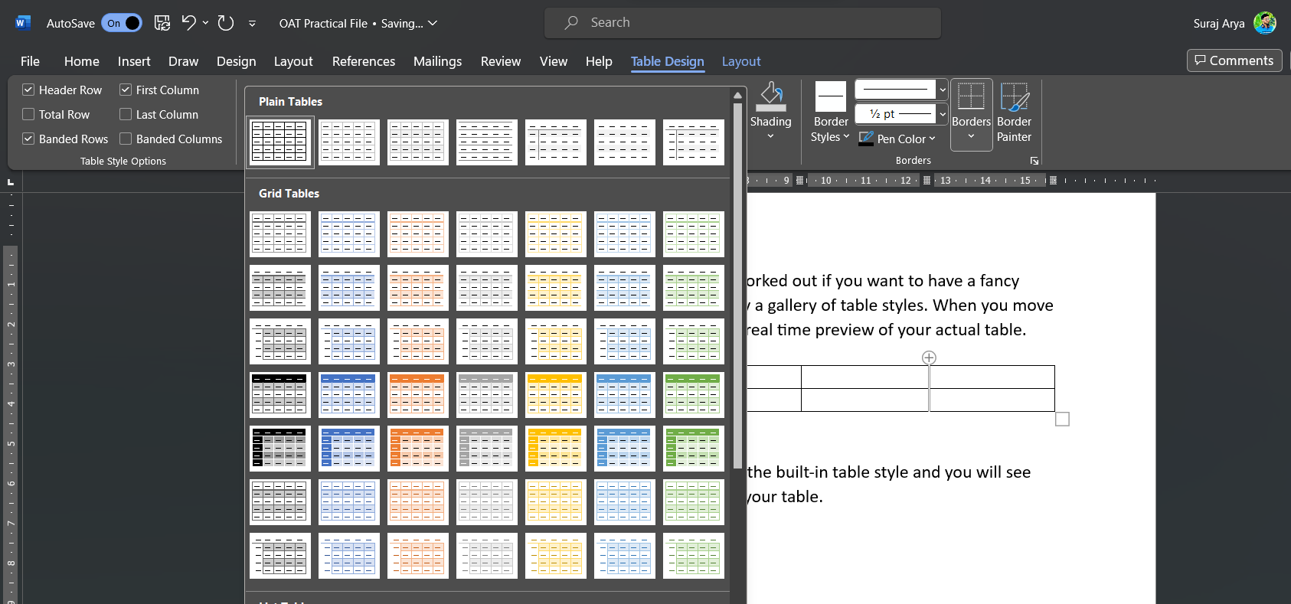

Step 4 - To select any of the styles, just click the built-in table style and you will see that the selected style has been applied on your table.



**Formatting cells**

After you create a table, you can format the entire table by using Table Styles. By resting your pointer over each of the preformatted table styles-

1. Click in the table that you want to format.
2. Under **Table Tools,** click the Design tab.
3. 3. In the Table Styles group, rest the pointer over each table style until you find a style that you want to use.
4. 4. Click the style to apply it to the table.
5. In the Table Style Options group, select or clear the check box next to each the table element to apply or remove the selected style.

**Border styles**

The **border** as the name suggests provides an outer/inner lining on the selected text/paragraph. A Border is a good alternative to the Fonts Styles such as Bold, Italics, and Underline and grabs much attention quickly without hardcore techniques. In MS Word there are multiple types of borders which are as follows:

* **Bottom Border**-Border at the bottom of the Paragraph.
* **Top Border-Border** at the top of the Paragraph.
* **Left Border**-Border on the left side of the Paragraph.
* **Right Border-**Border on the right side of the Paragraph.
* **No Border**-Removes all the borders.
* **All Borders**-Border on all sides of the Paragraph.
* **Outside Borders**-Border outside the Paragraph.
* **Inside Borders**-Border inside the Paragraph
* **Inside Horizontal Border**-Horizontal borders on both sides inside the Paragraph.
* **Inside Vertical Border-**Vertical borders on both sides inside the Paragraph.

Step 1: Select the text/Paragraph to apply Border.

**GEEKSFORGEEKS**

**Machine Learning** is the field of study that gives computers the capability to learn without being explicitly programmed. ML is one of the most exciting technologies that one would have ever come across. As it is evident from the name, it gives the computer that makes it more similar to humans: **The ability to learn**. Machine learning is actively being used today, perhaps in many more places than one would expect.

Python is a high-level, general-purpose and a very popular programming language. Python programming language (latest Python 3) is being used in web development, Machine Learning applications, along with all cutting-edge technology in Software Industry. Python Programming Language is very well suited for Beginners, also for experienced programmers with other programming languages like C++ and Java.

Competitive Programming is a mental sport which enables you to code a given problem under provided constraints. The purpose of this article is to guide every individual possessing a desire to excel in this sport. This article provides a detailed syllabus for Competitive Programming designed by industry experts to boost the preparation of the readers.

Step 2: Now, go to the **Borders** tab in the **Paragraph** menu under the **Home** bar.

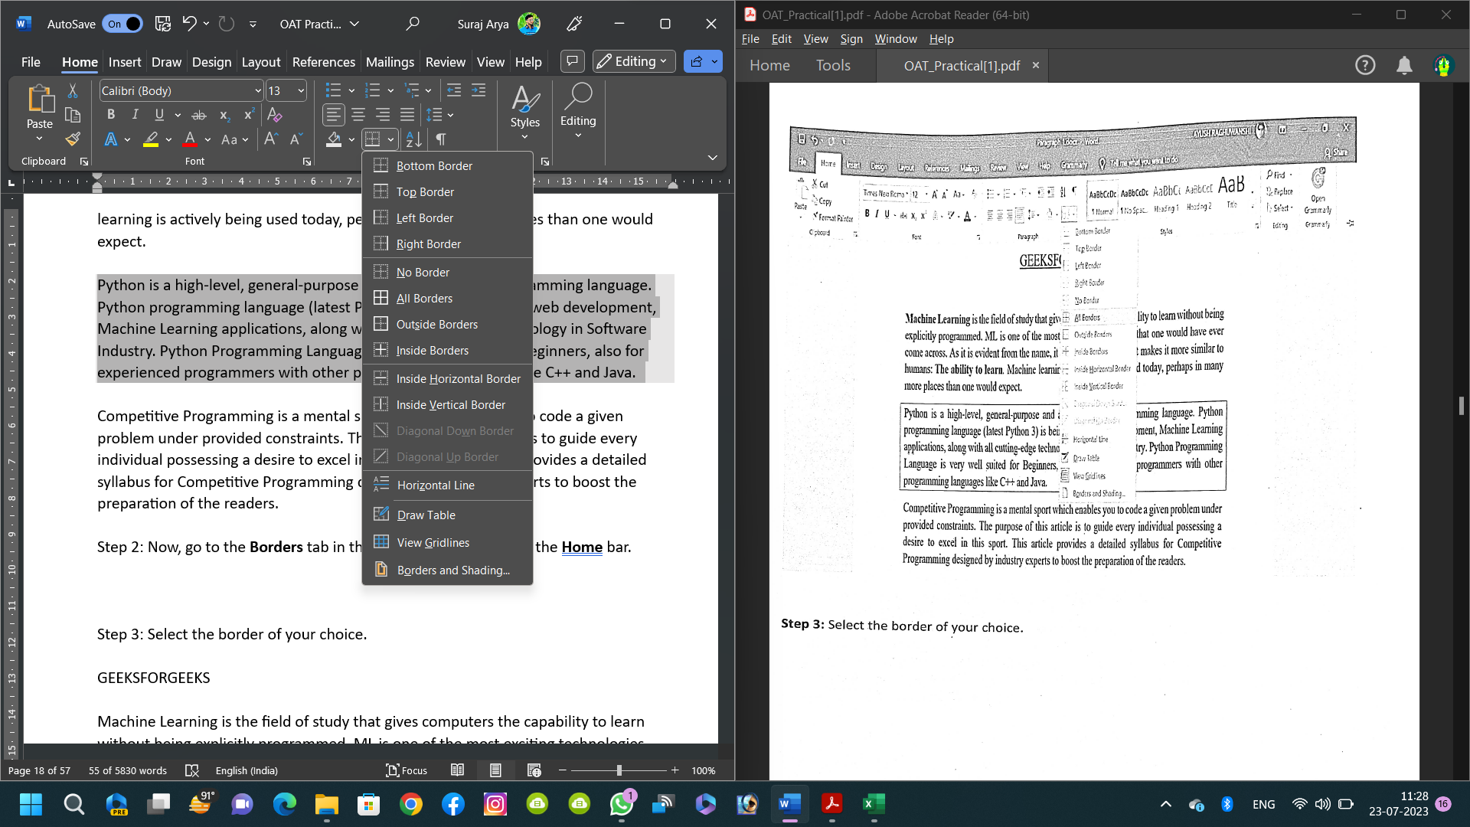

Step 3: Select the border of your choice.

**GEEKSFORGEEKS**

Machine Learning is the field of study that gives computers the capability to learn without being explicitly programmed. ML is one of the most exciting technologies that one would have ever come across. As it is evident from the name, it gives the computer that makes it more similar to humans: The ability to learn. Machine learning is actively being used today. perhaps in many more places than one would expect.

Python is a high-level, general-purpose and a very popular programming language. Python programming language (latest Python 3) is being used in web development. Machine Learning applications, along with all cutting-edge technology in Software Industry. Python Programming Language is very well suited for Beginners, also for experienced programmers with other programming languages like C++ and Java.

Competitive Programming is a mental sport which enables you to code a given problem under provided constraints. The purpose of this article is to guide every individual possessing a desire to excel in this sport. This article provides a detailed syllabus for Competitive Programming designed by industry experts to boost the preparation of the readers.

**Shading to a table**

1. Select the cells you want to change.
   * To select an entire table, click in the table, and then click the Table Move Handle in the upper-left corner.

* To select a row, column, cell, or group of cells, click and drag your mouse pointer to highlight the cells you want.

1. On the Table Tools Design tab (the Table Tools Layout tab in OneNote), click the Shading menu.
2. Under Theme Colors or Standard Colors, select the shading color you want. Or, for more color options, click More Colors. For more about on the Colors dialog box, see Choosing colors in the Colors dialog box.

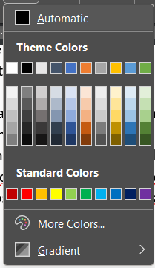

The **Shading** menu in PowerPoint offers several additional options:

* **Eyedropper** Click any color on your slide to apply that color to a selected cell or cells.
* **Picture** Select any picture from your computer or an internet location to add it to a selected cell or cells.
* **Gradient** Fill a selected cell or cells with one of several built-in gradients, or create your own custom gradient.
* **Texture** Fill a selected cell or cells with one of several built-in textures, or create your own custom texture.
* **Table Background** Quickly apply a color or picture to the background of an entire table.

**Merge Cells**

**Step 1 Select the Cells**

Use your mouse to select the cells you intend to merge.



Step 2 Merge Cells

Right-click any of the cells you have selected, and then select the "Merge Cells" option on the drop-down menu.

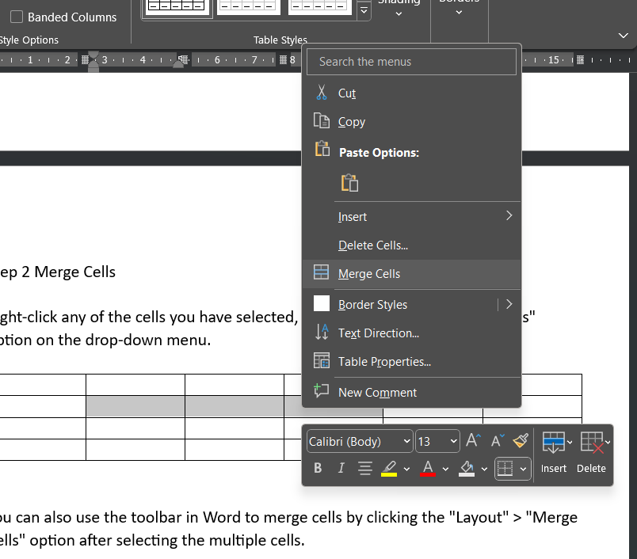

You can also use the toolbar in Word to merge cells by clicking the "Layout" > "Merge Cells" option after selecting the multiple cells.

**Split cells**

1. Select the cell that you want to split.
2. Select Layout > Split Cells.
3. Enter the number of columns or rows that you want to split the selected cell into, and then select OK.

**Inserting and Deleting a row in a table**

You can add a row above or below the cursor position.

1. Click where you want in your table to add a row or column and then click the **Layout** tab (this is the tab next to the **Table Design** tab on the ribbon).
2. To add rows, click Insert Above or Insert Below and to add columns, click **Insert** **Left** or **Insert Right**.

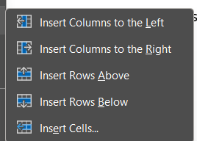

**Delete a row, cell, or table**

1. Click a row or cell in the table, and then click the Layout tab (this is the the Table Design tab on the ribbon).
2. Click Delete, and then click the option your need in the menu.

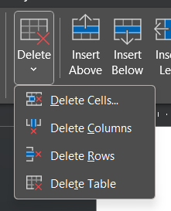

**Practical No:6**

**AIM-Create a document using inserting page breaks and column break, line spacing.**

**Inserting Page Breaks:**

There can be different positions where a user can insert page breaks:

1. Inserting a page break at the start
2. Inserting a page break in the middle (mostly used or the main thing you will use)
3. Inserting a page break at the end

**Steps to follow for inserting a page break at start:**

**Step 1:** Open MS Word on your PC.

**Step 2:** Open the file or document you want to make changes to or create a new file or document.

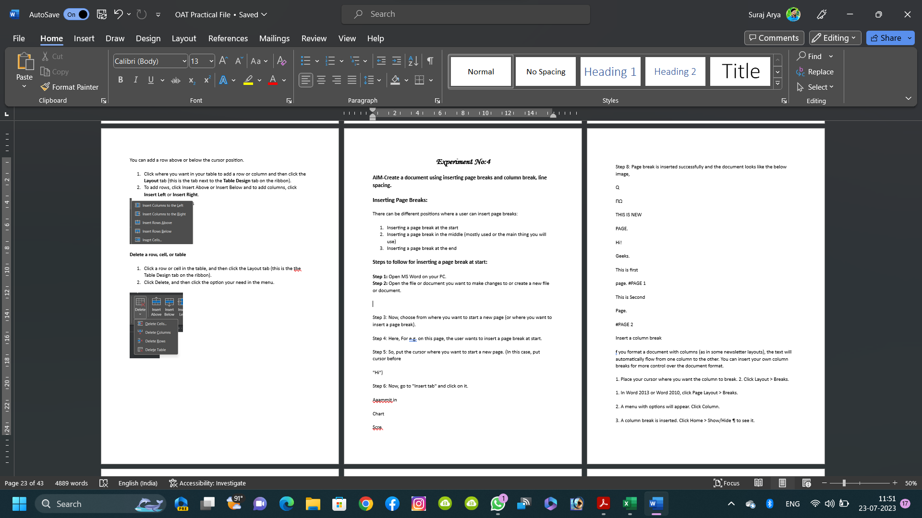

**Step 3**: Now, choose from where you want to start a new page (or where you want to insert a page break).

**Step 4:** Here, For e.g. on this page, the user wants to insert a page break at start.

**Step 5:** So, put the cursor where you want to start a new page. (In this case, put cursor before "Hi")

**Step 6:** Now, go to "Insert tab" and click on it.

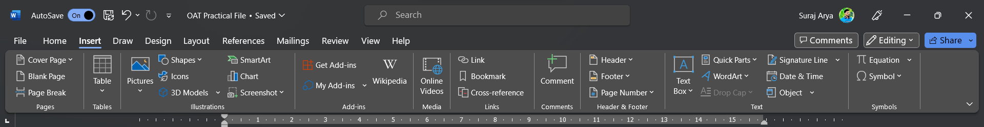



Step 7: Now, go to the page section and click on “page break”.





Step 8: Page break is inserted successfully and the document looks like the below image,



**Insert a column break**

f you format a document with columns (as in some newsletter layouts), the text will automatically flow from one column to the other. You can insert your own column breaks for more control over the document format.

1. Place your cursor where you want the column to break.
2. Click **Layout > Breaks**.

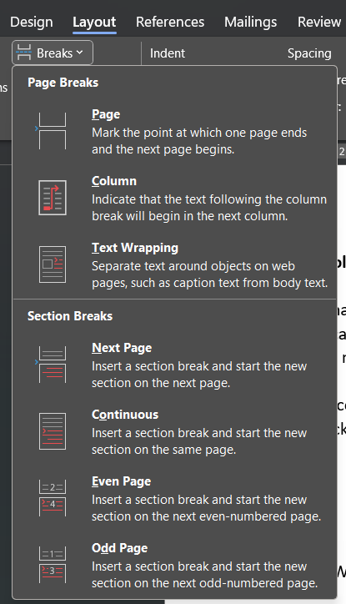

1. In Word 2013 or Word 2010, click **Page Layout > Breaks.**
2. A menu with options will appear. Click **Column.**
3. A column break is inserted. Click **Home > Show/Hide ¶ to see it**.





**Insert line spacing in Word**

Change the line spacing in an entire document

1. Go to Design > Paragraph Spacing.
2. Choose an option. To single space your document, select No Paragraph Space.

To return to the original settings later, go to Design > Paragraph Spacing and choose the option under Style Set. This may be Default or the name of style you're currently using.

Change the line spacing in a portion of the document

1. Select one or more paragraphs to update. Press Ctrl + A to select all.
2. Go to **Home > Line and Paragraph Spacing**
3. Select Line Spacing Options and choose an option in the Line spacing box.



1. Adjust the **Before and After** settings to change spacing between paragraphs.
2. Select **OK**.

**Practical No:7**

**AIM- Creating a document using subscript and superscript, justification of the document.**

Insert a superscript in the Word document, follow the below-mentioned steps-

**Step 1**: Open the Word document.

**Step 2:** Place cursor in the document where you want to insert a superscript.

**Step 3**: Go to the Home tab on the Ribbon and click on the Superscript

the Font group.

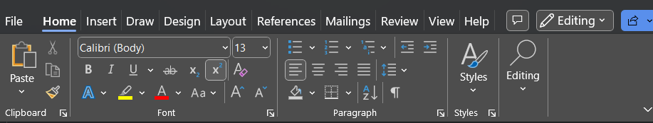



Step 4: A small sized cursor is blinked on the selected area, as shown in the below screenshot. Insert the text that you want to add in the superscript.

Find the square of 15 (15)

Find the square of 15 (152) -

15 × 15 = 225

**Insert subscript and superscript from the font dialog box**

**Step 1:** Open the Word document.

**Step 2:** Select the text where you want to insert subscript and superscript.

**Step 3:** Go the Font section. To the Home tab on the Ribbon and click Font

Dialog Box Launcher in the font section.

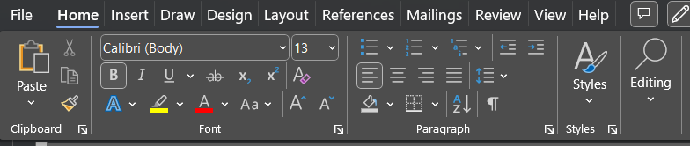



**Step 4:** A font dialog box will appear on the screen in which click either **Superscript** or **Subscript** **checkbox** that you want to insert and click on the **OK** button at the bottom of the screen.

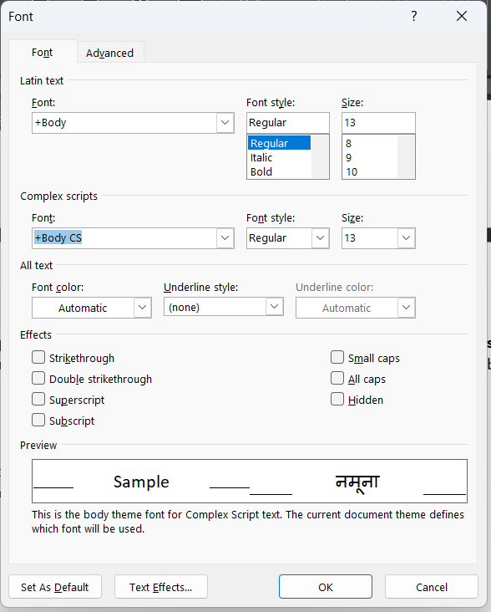

Once you did all the above-mentioned steps, you can see that Superscript or Subscript is inserted in the Word document.